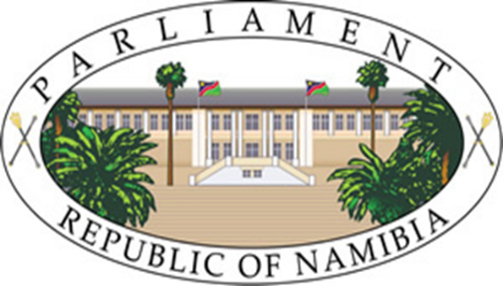
NATIONAL COUNCIL

OPENING REMARKS
BY
HON. LUKAS SINIMBO MUHA, MP
CHAIRPERSON OF THE NATIONAL COUNCIL

SECOND SPECIAL SITTING OF THE
7TH NATIONAL COUNCIL

NATIONAL COUNCIL CHAMBER, PARLIAMENT BUILDINGS, WINDHOEK

9 APRIL 2026

Honourable Members,
It is my honour to welcome you all to the 2nd Special Sitting of the 7th National Council. The session convened in light of the recent appointments made by Her Excellency Dr. Netumbo Nandi-Ndaitwah, President of the Republic of Namibia.

These historic appointments of seven Deputy Ministers from among our Council Members mark a significant milestone in strengthening the link between Government and the people.

However, these developments bring changes to the organisational structure of our standing committees and other committees of the Council.
Rule 171 of the National Council Standing Rules and Orders prohibits the Chairperson, Vice-Chairperson, and Deputy Ministers from serving on oversight committees, limiting their participation only to the Committee of Privileges and the Committee on Standing Rules, Orders and Business. Consequently, the seven newly appointed Deputy Ministers have been excused from their membership to standing committees.

To address this gap, the Committee on Rules, Orders and Business applied Rule 145(11), resulting in the reconstitution of committees.

The changes further created leadership vacancies in various committees. As result, the affected committees have since convened to re-constitute leadership, which will be announced shortly.

At this juncture, allow me to wholeheartedly congratulate the newly appointed Deputy Ministers:
- Hon. Moses //Khumub, Deputy Minister in the Office of the Vice-President;
- Hon. Suzan Hambeleleni Ndjaleka, Deputy Minister of Health and Social Services;
- Hon. Hans Shayandjeka Haikali, Deputy Minister of Works and Transport;
- Hon. Anselm Nyangana Marungu, Deputy Minister of Environment, Forestry and Tourism;
- Hon. Wenzel Kavaka, Deputy Minister of Information and Communication Technology;
- Hon. Edward Alfred Wambo, Deputy Minister of Home Affairs, Immigration, Safety and Security; and
- Hon. Theresia Brandt, Deputy Minister of Justice and Labour Relations;

On behalf of the National Council, and on my own behalf, I extend heartfelt congratulations to you on your well-deserved appointments. Importantly, you are now expected to balance your regional and national responsibilities fairly.
I am confident that, with the support of your colleagues, you will succeed in fulfilling both mandates.
We are profoundly grateful to Her Excellency Dr. Netumbo Nandi-Ndaitwah for these historic appointments.
With these remarks, I warmly welcome you all to this special sitting of the National Council.
I thank you

